January 8, 2024
Dear Parents and Community Members:
We are pleased to present you with the Annual Education Report (AER) which provides key information on the 2022-2023 educational progress for Turrill Elementary. The AER addresses the complex reporting information required by federal and state laws. The school’s report contains information about student assessment, accountability, and teacher quality. If you have any questions about the AER, please contact Kelly Vangel for assistance.
The AER is available for you to review electronically by visiting the following web site School Index, or you may review a copy in the main office at your child’s school.
For the 2022-23 school year, schools were identified based on previous years’ performance using definitions and labels as required in the Every Student Succeeds Act (ESSA). A Targeted Support and Improvement (TSI) school is one that had at least one underperforming student subgroup in 2022-23. An Additional Targeted Support (ATS) school is one that had a student subgroup performing at the same level as the lowest 5% of all schools in the state in 2022-23. A Comprehensive Support and Improvement (CSI) school is one whose performance was in the lowest 5% of all schools in the state or had a graduation rate at or below 67% in 2022-23. Some schools are not identified with any of these labels. In these cases, no label is given.

Turrill Elementary was identified as a “STATE HAS NOT BEEN GIVEN ONE OF THESE LABELS” school.
At Turrill Elementary, our focus continues to be on improving proficiency in the core areas of Reading, Writing, and Mathematics. Additionally, we have made a strong effort to offer parent engagement to support the instruction and learning that takes place in the classroom and at home. As a staff we have created monthly calendars to engage our parents in core curriculum instruction. Also, in order to meet the needs of our students our school has been focusing professional development activities on maximizing student-centered instruction in all classrooms at all grade levels as part of Tier I instruction and thereby impacting all students. Other building initiatives and programs offered at Turrill include:

- An MTSS (Multi-Tiered System of Supports) plan for struggling students in ELA
- Three Learning Coaches to support instruction in the classroom
- Peer to peer support with our LINKS program
- 4th and 5th grade TAG (Talented and Gifted) Program
- Math Investigations program focused on improving mathematical thinking
- Reading and Writing Workshop
- Reading Recovery
- Before and After School Intervention
- Updated curriculum in the areas of Reading, Writing, Science, and Social Studies including more student-centered and inquiry-based instruction

State law requires that we also report additional information.
Process for Assigning Pupils to a School
Students attending Lapeer Community Schools are assigned to school buildings based on their residence. Parents may request that their children attend a different building by completing an In-District Schools of Choice Request and submitting it to any school building in the district. Details regarding the Schools-of-choice process can be obtained from the district website, www.lapeerschools.org.

Status of the 3 to 5 Year School Improvement Plan
At Turrill we continue to work with our School Improvement Plan (SIP) goals. The five goals are as follows:
- All students will become proficient in mathematics
- All students will become proficient readers
- All students will become proficient in writing
- All students will be proficient in science
- All students and staff will participate in building a positive climate and culture at Turrill.

For Math and ELA (Reading and Writing), NWEA MAP test scores and M-STEP scores for the 2021-2022 and 2022-2023 school years were used to gauge progress on these goals. At the beginning of each school year, growth goals in reading and math are determined for each student through the computer adaptive NWEA MAP assessments. Student progress towards the growth goal is then determined after administration of the Spring NWEA MAP assessments.
The percentage of student growth in ELA MAP, Math MAP and M-STEP is shown in the following tables for the previous two school years:

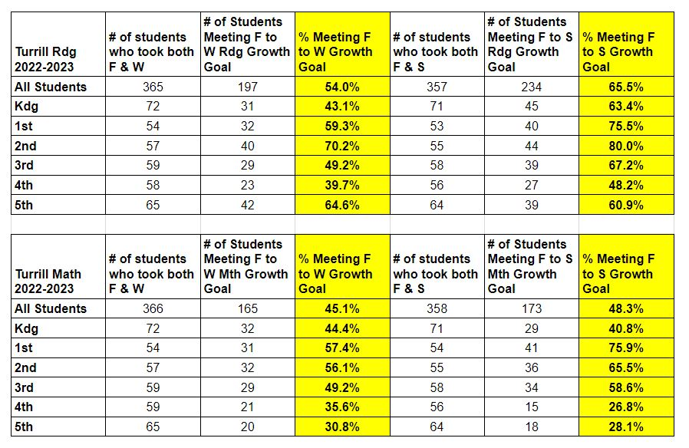
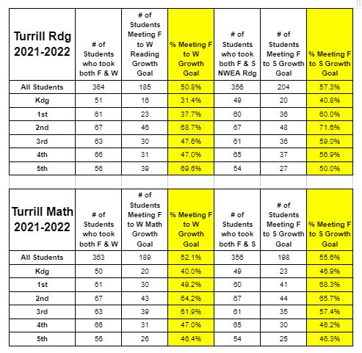
State law requires that we also report additional information:
Specialized Schools in the District
Specialized schools provide alternative educational opportunities for students on either a part-time or full-time basis. In addition to the regular K-12 program provided by Lapeer Community Schools, the district has students attending five specialized school programs: Special education for the most severely handicapped students, Community High School, Lapeer County Educational and Technical Center and two options utilizing the Year-Round calendar at both the K-5 and 6-8 grade levels. ·
· The Lapeer Intermediate School District offers programs for the most severe mentally, physically and emotionally impaired students. Most of these programs are housed at the Lapeer County Educational and Technical Center. ·
· Lapeer Community High School serves “at-risk” youths ages 14-18 in an alternative environment. The school provides a curriculum designed to develop employability and social skills as well as academic skills. A range of services address problems such as poor attendance, poor academic performance and behavioral issues. ·
· The Center for Innovation at the West Campus is a program that offers a series of project based learning classes, a Project Lead the Way science program for students in grades 6-12, college on campus courses, and other programs. Many students in grades 6-12 opt to spend a portion of their day at the CFI campus in order to take advantage of these many educational options. ·
· The Lapeer County Educational and Technical Center provides vocational education and related services to high school students from all of the county high schools. Students in the 15 programs learn job specific skills to help them prepare for employment upon graduation. They also learn academic skills in an applied setting.
· Rolland-Warner Year-Round Middle School is a program for students in grades 6-8 that operates on a balanced calendar. Students attend school the same number of days as traditional calendar students, but have a shorter summer break and more frequent week-long breaks during the school year. This program is housed at the Rolland-Warner 6/7 Campus. Over 100 students participated in the Year-Round Middle School program this past school year. ·
· Turrill Year-Round Elementary School is a program for students in grades E5-5 that operates on a balanced calendar. Students attend school the same number of days as traditional calendar students, but have a shorter summer break and more frequent week-long breaks during the school year. During these week-long breaks, students can opt to attend intersession camps for a nominal fee. Turrill has over 400 students that take advantage of this option for their elementary school years.
Accessing the Core Curriculum
The core curriculum of Lapeer Community Schools is modeled after the Michigan Department of Education’s (MDE) K-12 Curriculum and Standards. Our teachers have developed pacing guides, lesson plans and assessments to align with MDE grade or course level specific expectations. To access the core curriculum online, visit http://www.mich.gov/mde; click on Curriculum & Instruction on the menu, and then select Grade Level or High School Content Expectations.

Parent Teacher Conference Participation
Turrill continues to strive for 100% participation for parent/teacher conferences. In Fall 2023, Turrill had 92% participation for parent/teacher conferences. In the 2022-2023 school year we had 89.3% parent participation for parent/teacher conferences. In the 2021-2022 school year we had 96% parent participation for parent/teacher conferences. In the 2020-2021 school year we have 96% parent participation.
In closing, Turrill Elementary is continuing to work and grow in meeting the needs of all our students. We are continually looking for ways to meet the needs of our struggling learners while helping all students. Our overall goal is for 100% proficiency in all content areas and the staff is dedicated to delivering a standards-based curriculum through high-quality instruction. With a continued focus on improving instruction and curriculum I look forward to the long-term growth and success at Turrill Elementary.

Sincerely,
Kelly Vangel
Turrill Elementary
Principal
kelly.vangel@lapeerschools.org
(810) 667-2438

